
A 10
SET NO : 1

Sreenidhi Institute of Science & Technology
(An Autonomous Institution)
Code No: 101EE43

B. TECH. I – Year II – Semester Examinations, July/Aug, 2011 (Regular)
NETWORK ANALYSIS ( ECE & ECM )

Time: 3 Hours Max. Marks : 70

Note : No additional answer sheets will be provided.

Part-A (Objective Type)
Max.Marks:20

Answer all QUESTIONS.

1. What are linear and non-linear elements? Give examples.

2. Differentiate between active and passive elements.

3. Two coils are wound on a cylindrical form as shown with self inductance L₁,L₂ and mutual inductance M. Voltages v₁ and v₂ are applied and dot is placed as shown. Write the voltage equations for v₁ and v₂.
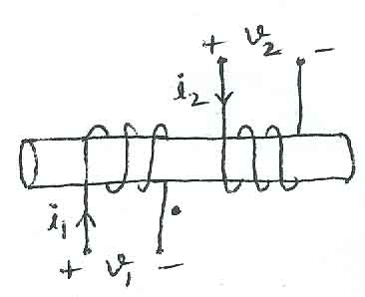

4. What is co-efficient of coupling? Explain.

5. Define the following terms :
a) Graph b) Chord c) Co-trees of the graph

6. Explain incidence matrix.

7. In a DC circuit, show that the maximum power delivered to the load is when
R_{Load} = R_{th}.

8. Explain low pass and high pass filters.

9. What is the impedance from of single capacitor in Laplace transform domain?

10. What is time constant ? Explain with reference to RL and RC circuits.

Part – B
Max. Marks: 50
ANSWER ANY FIVE QUESTIONS.
EACH QUESTION CARRIES 10 MARKS.

1. a) Derive the expressions for energy stored in the inductor and capacitor. [ 5 ]

b) Use mesh analysis to obtain 'i₀' in the circuit shown. [ 5 ]
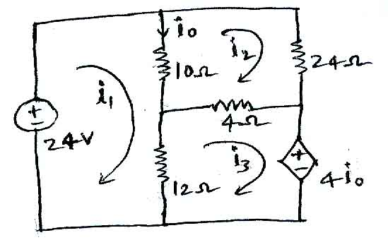

2. a) For the series parallel circuit shown below, find the equivalent admittance. [ 6 ]
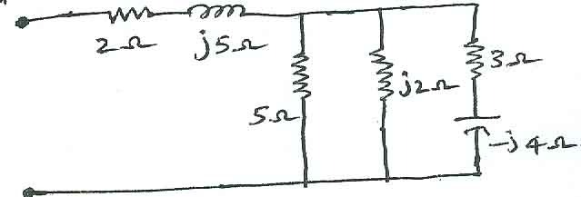
b) What is the voltage across A and B in the circuit shown below. [ 4 ]
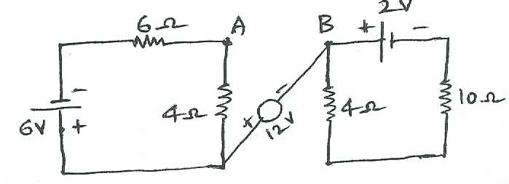
3. a) Derive the expression for resonant frequency and Q factor in series RLC circuit. [ 5 ]

b) Obtain the RMS and average value of the full wave rectified sine wave whose amplitude is V_{m}. [ 5 ]

4. Define basic cutset and basic tie set matrices and write these for the following graphs by taking 1,2,3 as three branches as shown in figure below.
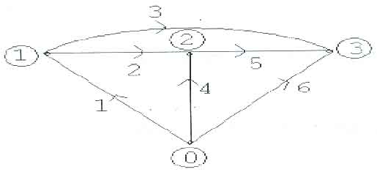
5. Explain following theorems with neat circuit diagram.
a) Norton's theorem b) Tellegen's theorem

6. a) Fig a) and Fig b) show two networks. Connect them in series and determine the Z-parameter of the overall network. [ 6 ]
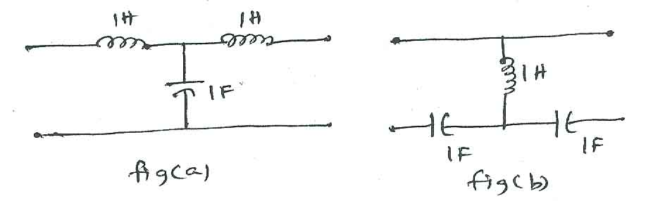

b) Obtain the overall parameters for series and parallel connection of two twoport networks. [ 4 ]

7. a) Find the ABCD parameters of the resistive two port network shown below with R₁=R₄=10 ohm, R₂=R₃=5 ohms. [ 5 ]
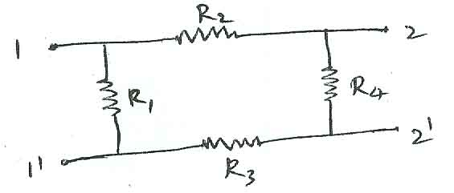
b) The Y parameters of the 2-port network are y₁₁=0.6 mho, y₂₂=1 and y₁₂=0.3 mho = y₂₁. Determine the ABCD parameters. [ 5 ]

8. a) Derive the current expression in transient response of series R - L circuit with DC excitation. [ 5 ]

b) Write a note on initial conditions in basic circuit elements. Explain about Transient response of R-C (series) circuit using differential equation approach. [ 5 ]

-- 00 -- 00 --

